### EXP 3 – SHIFT RESISTER

library IEEE;

use IEEE.STD_LOGIC_1164.ALL;

-- Uncomment the following library declaration if using

-- arithmetic functions with Signed or Unsigned values

--use IEEE.NUMERIC_STD.ALL;

-- Uncomment the following library declaration if instantiating

-- any Xilinx primitives in this code.

--library UNISIM;

--use UNISIM.VComponents.all;

entity shiftreg is

Port ( si : in STD_LOGIC; clk : in STD_LOGIC;

so : out STD_LOGIC;

pin : in STD_LOGIC_VECTOR (3 downto 0); po : out STD_LOGIC_VECTOR (3 downto 0); sel : in STD_LOGIC_VECTOR (1 downto 0));

end shiftreg;

architecture Behavioral of shiftreg is

signal temp:STD_LOGIC_VECTOR( 3 downto 0); begin

process(clk) begin

if(clk'event and clk='1')then case sel is

when"00"=> temp<= si&temp(3 downto 1);

so <=temp(3);

when"01"=> temp<= si&temp(3 downto 1); po<=temp;

when others=>null; end case;

end if;

end process; end Behavioral;

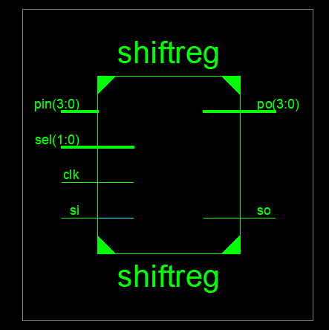

### TEST BENCH

LIBRARY ieee;

USE ieee.std_logic_1164.ALL;

-- Uncomment the following library declaration if using

-- arithmetic functions with Signed or Unsigned values

--USE ieee.numeric_std.ALL; ENTITY shifttest IS

END shifttest;

ARCHITECTURE behavior OF shifttest IS

-- Component Declaration for the Unit Under Test (UUT) COMPONENT shiftreg

PORT(

si : IN std_logic; clk : IN std_logic; so : OUT std_logic;

pin : IN std_logic_vector(3 downto 0); po : OUT std_logic_vector(3 downto 0); sel : IN std_logic_vector(1 downto 0)

);

END COMPONENT;

--Inputs

signal si : std_logic := '0'; signal clk : std_logic := '0';

signal pin : std_logic_vector(3 downto 0) := (others => '0'); signal sel : std_logic_vector(1 downto 0) := (others => '0');

--Outputs signal so : std_logic;

signal po : std_logic_vector(3 downto 0);

-- Clock period definitions

constant clk_period : time := 10 ns; BEGIN

-- Instantiate the Unit Under Test (UUT) uut: shiftreg PORT MAP (

si => si, clk => clk, so => so, pin => pin, po => po, sel => sel

);

-- Clock process definitions clk_process :process

begin

clk <= '0';

wait for clk_period/2; clk <= '1';

wait for clk_period/2; end process;

-- Stimulus process stim_proc: process begin

sel<="00"; si<='1';

-- hold reset state for 100 ns. wait for 100 ns;

sel<="01"; si<='1';

wait for 100 ns; sel<="10"; pin<="1100";

wait for 100 ns; sel<="11"; pin<="1100";

--=wait for clk_period*10;

-- insert stimulus here wait;

end process; END;

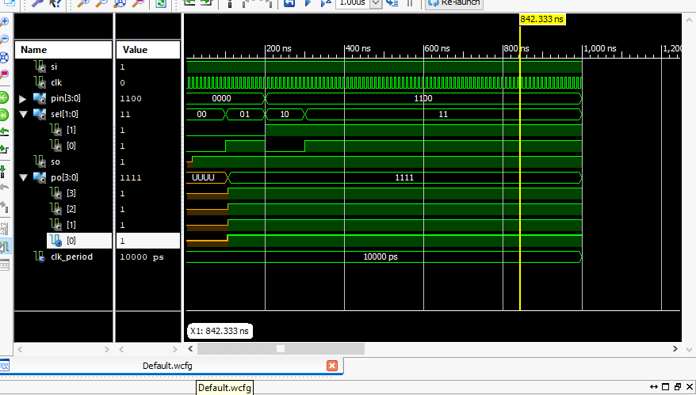

### UCF FILE (SHIFT REGISTER)

NET clk LOC = P183; NET Reset LOC = P102; NET md(0) LOC = P101; NET md(1) LOC = P100; NET si LOC = P97;

NET so LOC = P156; NET pi(0) LOC = P87; NET pi(1) LOC = P86; NET pi(2) LOC = P85; NET pi(3) LOC = P81; NET po(0) LOC = P162; NET po(1) LOC = P165; NET po(2) LOC = P166;

NET po(3) LOC = P167;

**Final Report**

Final Results

RTL Top Level Output File Name : shiftreg.ngr Top Level Output File Name : shiftreg

Output Format : NGC

Optimization Goal : Speed

Keep Hierarchy : No

Design Statistics

# IOs 13

Cell Usage :

# BELS 6

# LUT2 2

# LUT3 4

|  |  |  |
| --- | --- | --- |
| # | FlipFlops/Latches | : 9 |
| # | FD | : 4 |
| # | FDE | : 5 |
| # | Clock Buffers | : 1 |
| # | BUFGP | : 1 |
| # | IO Buffers | : 8 |
| # | IBUF | : 3 |
| # | OBUF | : 5 |

=========================================================================

Device utilization summary:

Selected Device : 3s400pq208-5

Number of Slices: 5 out of 3584 0% Number of Slice Flip Flops: 9 out of 7168 0% Number of 4 input LUTs: 6 out of 7168 0%

|  |  |  |  |
| --- | --- | --- | --- |
| Number of IOs: | 13 |  | |
| Number of bonded IOBs: | 9 out of | 141 | 6% |
| Number of GCLKs: | 1 out of | 8 | 12% |

Partition Resource Summary:

No Partitions were found in this design.

TIMING REPORT

NOTE: THESE TIMING NUMBERS ARE ONLY A SYNTHESIS ESTIMATE.

FOR ACCURATE TIMING INFORMATION PLEASE REFER TO THE TRACE REPORT GENERATED AFTER PLACE-and-ROUTE.

Clock Information:

+ + +

Clock Signal | Clock buffer(FF name) | Load |

+ + +

clk | BUFGP | 9 |

+ + + Asynchronous Control Signals Information:

No asynchronous control signals found in this design Timing Summary:

Speed Grade: -5

Minimum period: 2.230ns (Maximum Frequency: 448.340MHz) Minimum input arrival time before clock: 3.538ns

Maximum output required time after clock: 6.216ns Maximum combinational path delay: No path found

Timing Detail:

All values displayed in nanoseconds (ns)

### EXP 4 – MOD –N COUNTER

library IEEE;

use IEEE.STD_LOGIC_1164.ALL;

use IEEE.STD_LOGIC_unsigned.ALL; use IEEE.NUMERIC_STD.ALL;

-- Uncomment the following library declaration if using

-- arithmetic functions with Signed or Unsigned values

--use IEEE.NUMERIC_STD.ALL;

-- Uncomment the following library declaration if instantiating

-- any Xilinx primitives in this code.

--library UNISIM;

--use UNISIM.VComponents.all; entity mod5ex is

Port ( clk : in STD_LOGIC;

clr : in STD_LOGIC;

q : inout STD_LOGIC_VECTOR (2 downto 0));

end mod5ex;

architecture Behavioral of mod5ex is

signal count: std_logic_vector(2 downto 0); begin

process(clk) begin

if (clr='1') then count <= "000"; elsif (rising_edge (clk)) then

if (count="100") then count <= "000"; else

count<=count+ 1; end if;

end if;

end process; q<=count;

end Behavioral;

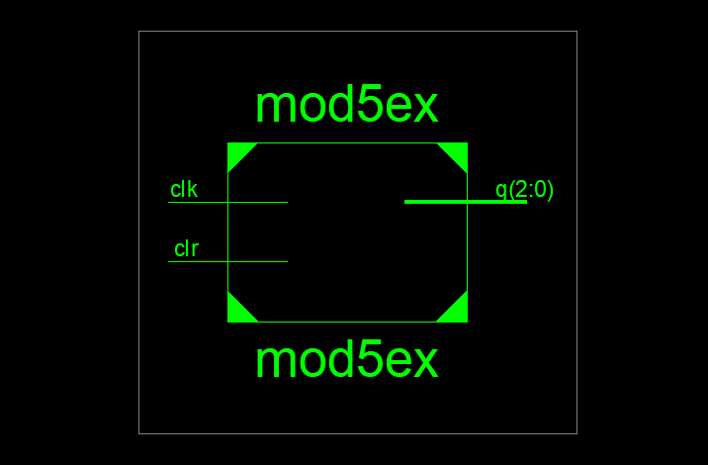

### TEST BENCH

LIBRARY ieee;

USE ieee.std_logic_1164.ALL;

-- Uncomment the following library declaration if using

-- arithmetic functions with Signed or Unsigned values

--USE ieee.numeric_std.ALL; ENTITY mod5test IS

END mod5test;

ARCHITECTURE behavior OF mod5test IS

-- Component Declaration for the Unit Under Test (UUT) COMPONENT mod5ex

PORT(

clk : IN std_logic; clr : IN std_logic;

q : INOUT std_logic_vector(2 downto 0)

);

END COMPONENT;

--Inputs

signal clk : std_logic := '0'; signal clr : std_logic := '0';

--BiDirs

signal q : std_logic_vector(2 downto 0);

-- Clock period definitions

constant clk_period : time := 10 ns; BEGIN

-- Instantiate the Unit Under Test (UUT) uut: mod5ex PORT MAP (

clk => clk, clr => clr, q => q

);

-- Clock process definitions clk_process :process

begin

clk <= '0';

wait for 10 ns; clk <= '1';

wait for 10 ns; end process;

-- Stimulus process stim_proc: process begin

clr<='1';

-- hold reset state for 100 ns. wait for 20 ns;

clr<='0';

-- hold reset state for 100 ns. wait for 20 ns;

-- hold reset state for 100 ns.

-- wait for 100 ns;

-- wait for clk_period*10

-- insert stimulus here wait;

end process;

END;

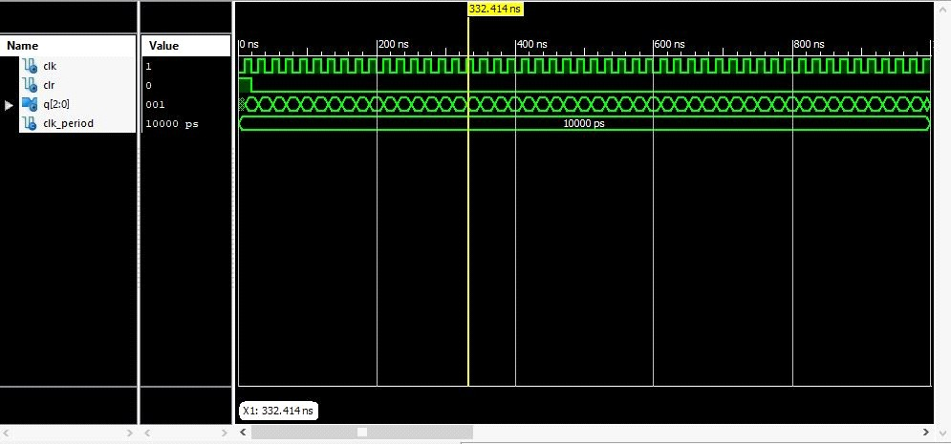

### Final Report

=========================================================================

* Final Report *

=========================================================================

Final Results

RTL Top Level Output File Name : mod5ex.ngr Top Level Output File Name : mod5ex Output Format : NGC

Optimization Goal : Speed

Keep Hierarchy : No

Design Statistics

# IOs 5

Cell Usage :

|  |  |  |
| --- | --- | --- |
| # BELS |  | : 3 |
| # | LUT2 | : 1 |
| # | LUT3 | : 2 |

# FlipFlops/Latches 3

# FDC 3

# Clock Buffers 1

# BUFGP 1

# IO Buffers 4

# IBUF 1

# OBUF 3

=========================================================================

Device utilization summary:

Selected Device : 3s400pq208-5

Number of Slices: 2 out of 3584 0% Number of Slice Flip Flops: 3 out of 7168 0% Number of 4 input LUTs: 3 out of 7168 0%

|  |  |  |  |
| --- | --- | --- | --- |
| Number of IOs: | 5 |  | |
| Number of bonded IOBs: | 5 out of | 141 | 3% |
| Number of GCLKs: | 1 out of | 8 | 12% |

Partition Resource Summary:

No Partitions were found in this design.

### EXP 5 – FIFO

library IEEE;

use IEEE.STD_LOGIC_1164.ALL; use IEEE.STD_LOGIC_ARITH.ALL;

use IEEE.STD_LOGIC_UNSIGNED.ALL;

use IEEE.numeric_std.all;

-- Uncomment the following library declaration if using

-- arithmetic functions with Signed or Unsigned values

--use IEEE.NUMERIC_STD.ALL;

-- Uncomment the following library declaration if instantiating

-- any Xilinx primitives in this code.

--library UNISIM;

--use UNISIM.VComponents.all; entity fifo_vhdl is

Port ( clk,rst : in STD_LOGIC;

enr : in STD_LOGIC; --enable read,should be '0' when not in use. enw : in STD_LOGIC; --enable write,should be '0' when not in use. dataout : out STD_LOGIC_VECTOR (3 downto 0); --output data datain : in STD_LOGIC_VECTOR (3 downto 0); --input data

FF_empty,clk_div : out STD_LOGIC; --set as '1' when the queue is empty FF_full : out STD_LOGIC); ---set as '1' when the queue is full

end fifo_vhdl;

architecture Behavioral of fifo_vhdl is

type memory_type is array (0 to 7) of std_logic_vector(3 downto 0); signal memory: memory_type :=(others=>(others=> '0'));

signal readptr,writeptr: std_logic_vector(2 downto 0) :="000"; signal count : std_logic_vector(2 downto 0):="000";

signal newclk : std_logic;

signal count1 : std_logic_vector(25 downto 0); begin

clk_div1: process(clk,rst) begin

if rst='1' then count1<=(others =>'0');

elsif clk'event and clk='1' then count1<=count1+'1';

end if;

end process;

newclk<=count1(25); clk_div<=count1(25);

fifo_emty_full: process(readptr,writeptr,count) begin

if(count="000") then FF_empty<='1'; FF_full<='0'; elsif(count="111")then FF_empty<='0'; FF_full<='1';

end if;

end process;

count1_reptr_wdptr: process(newclk,rst,enr,enw,readptr,writeptr)

begin

if rst='1' then count<="000"; readptr<=(others=>'0'); writeptr<=(others=>'0');

else if newclk'event and newclk='1' then if enw='1' and enr='0' then count<=count+'1';

if count="111" then count<=count;

end if; readptr<=readptr; writeptr<=writeptr+1;

elsif enw='0' and enr='1' then count<=count-'1';

if count="000" then count<=count;

end if; readptr<=readptr+1; writeptr<=writeptr; else

null; end if; end if; end if;

end process;

mem_read_write:process(newclk,count,enw,enr)

begin

if(newclk'event and newclk='1') then if enw='1' and enr='0' then

if count /="111" then memory(conv_integer(writeptr))<=datain; end if;

elsif enw='0' and enr='1' then if count /="000" then

dataout<=memory(conv_integer(readptr)); end if;

end if; end if;

end process; end Behavioral;

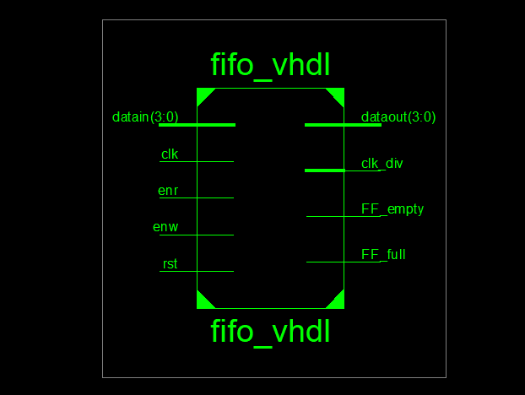

**TEST BENCH**

## LIBRARY ieee;

USE ieee.std_logic_1164.ALL;

## -- Uncomment the following library declaration if using

-- arithmetic functions with Signed or Unsigned values

## --USE ieee.numeric_std.ALL;

ENTITY fifo_test IS END fifo_test;

## ARCHITECTURE behavior OF fifo_test IS

-- Component Declaration for the Unit Under Test (UUT) COMPONENT fifo_vhdl

## PORT(

clk : IN std_logic; rst : IN std_logic; enr : IN std_logic; enw : IN std_logic;

## dataout : OUT std_logic_vector(3 downto 0); datain : IN std_logic_vector(3 downto 0); FF_empty : OUT std_logic;

clk_div : OUT std_logic; FF_full : OUT std_logic

## );

END COMPONENT;

## --Inputs

signal clk : std_logic := '0'; signal rst : std_logic := '0'; signal enr : std_logic := '0'; signal enw : std_logic := '0';

## signal datain : std_logic_vector(3 downto 0) := (others => '0');

--Outputs

## signal dataout : std_logic_vector(3 downto 0); signal FF_empty : std_logic;

signal clk_div : std_logic; signal FF_full : std_logic;

## -- Clock period definitions

constant clk_period : time := 10 ns; constant clk_div_period : time := 10 ns;

## BEGIN

-- Instantiate the Unit Under Test (UUT) uut: fifo_vhdl PORT MAP (

## clk => clk, rst => rst, enr => enr, enw => enw,

dataout => dataout, datain => datain, FF_empty => FF_empty,

## clk_div => clk_div, FF_full => FF_full

);

## -- Clock process definitions clk_process :process

begin

## clk <= '0';

wait for clk_period/2; clk <= '1';

## wait for clk_period/2; end process;

clk_div_process :process begin

## clk_div <= '0';

wait for clk_div_period/2; clk_div <= '1';

## wait for clk_div_period/2; end process;

-- Stimulus process stim_proc: process begin

## -- hold reset state for 100 ns. rst<='1';

enr<='0';

## enw<='1'; dataout<="0110";

wait for 100 ns; rst<='0';

## enr<='0';

enw<='1'; dataout<="1100"; wait for 100 ns; rst<='0';

## enr<='1';

enw<='0'; dataout<="1100"; wait for 100 ns;

## wait for clk_period*10;

-- insert stimulus here wait;

## end process;

END;

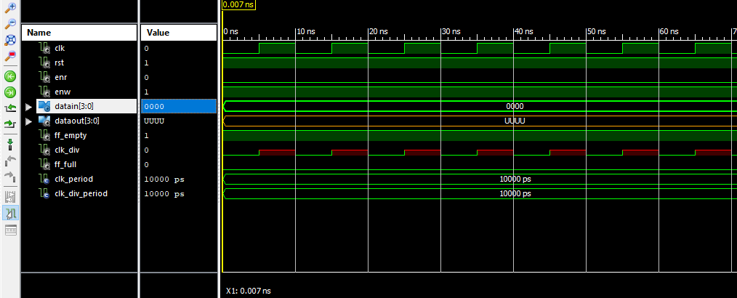

=========================================================================

* Final Report *

=========================================================================

Final Results

RTL Top Level Output File Name : fifo_vhdl.ngr Top Level Output File Name : fifo_vhdl Output Format : NGC

Optimization Goal : Speed

Keep Hierarchy : No

Design Statistics

# IOs 15

|  |  |  |
| --- | --- | --- |
| Cell Usage : |  | |
| # BELS |  | : 96 |
| # GND |  | : 1 |
| # INV |  | : 4 |
| # LUT1 |  | : 25 |
| # LUT2 |  | : 4 |
| # LUT3 |  | : 6 |
| # LUT4 |  | : 4 |
| # MUXCY |  | : 25 |
| # VCC |  | : 1 |
| # XORCY |  | : 26 |
| # FlipFlops/Latches | : 41 |  |
| # FDC |  | : 26 |
| # FDCE |  | : 9 |

|  |  |  |
| --- | --- | --- |
| # | FDE | : 4 |
| # | LD | : 2 |
| # RAMS |  | : 4 |
| # | RAM16X1D | : 4 |

# Clock Buffers 1

# BUFGP 1

# IO Buffers 14

# IBUF 7

# OBUF 7

=========================================================================

Device utilization summary:

|  |  |  |  |
| --- | --- | --- | --- |
| Selected Device : 3s400pq208-5 |  | | |
| Number of Slices: | 25 out of 3584 |  | 0% |
| Number of Slice Flip Flops: | 39 out of 7168 | 0% |  |
| Number of 4 input LUTs: | 51 out of 7168 |  | 0% |
| Number used as logic: | 43 |  |  |
| Number used as RAMs: | 8 |  |  |
| Number of IOs: | 15 |  |  |
| Number of bonded IOBs: | 15 out of 141 |  | 10% |
| IOB Flip Flops: | 2 |  |  |
| Number of GCLKs: | 1 out of 8 |  | 12% |

Partition Resource Summary:

No Partitions were found in this design.

# EXP 6 – LCD

library IEEE;

use IEEE.STD_LOGIC_1164.ALL; use IEEE.STD_LOGIC_ARITH.ALL;

use IEEE.STD_LOGIC_UNSIGNED.ALL;

entity LCD_SIMPLE_Practice is

Port ( rst,clk : in STD_LOGIC; lcd_RS : out STD_LOGIC;

-- din : in std_logic_vector(7 downto 0);

--LED : OUT std_logic_vector(7 downto 0); lcd_EN : out STD_LOGIC;

data_out : out STD_LOGIC_VECTOR (7 downto 0)); end LCD_SIMPLE_Practice;

architecture Behavioral of LCD_SIMPLE_Practice is signal div_count : std_logic_vector(20 downto 0); signal clk_new : std_logic;

type state is(reset,fuction,mode,cur,clear,d0,d1,d2,fuction1,mode1,cur1,clear1,d01,d11,d21); signal pss,nx : state;

begin

--LED<=din;

clk_DIV: process(clk,rst)

begin

if rst= '1' then div_count<= (others=>'0');

elsif clk'event and clk='1' then div_count<= div_count + '1'; end process;

clk_new<= div_count(20);

p_state_transactin: process (clk_new,rst) begin

if rst='1' then pss<=reset;

elsif clk_new'event and clk_new= '1' then pss<= nx;

end if;

end process;

LCD_working: process(pss) begin

case pss is when reset => lcd_RS<='0'; lcd_EN<='1'; nx<= fuction;

data_out<="00111100"; --3Ch

when fuction => lcd_RS<='0'; lcd_EN<='1';

data_out<="00111100"; --3Ch nx<= fuction

when fuction1 => lcd_RS<='0'; lcd_EN<='0';

data_out<="00111100"; --3Ch nx<= mode;

when mode => lcd_RS<='0'; lcd_EN<='1';

data_out<="00000110"; --06h nx<= mode1;

when mode1 => lcd_RS<='0'; lcd_EN<='0';

data_out<="00000110"; --06h nx<= cur;

when cur => lcd_RS<='0'; lcd_EN<='1';

data_out<="00001100"; --0Ch

nx<= cur1;

when cur1 => lcd_RS<='0'; lcd_EN<='0';

data_out<="00001100"; --0Ch nx<= clear;

when clear => lcd_RS<='0'; lcd_EN<='1';

data_out<="00000001"; --01h nx<= clear1;

when clear1 => lcd_RS<='0'; lcd_EN<='0';

data_out<="00000001"; --01h nx<= d0;

when d0 => lcd_RS<='1'; lcd_EN<='1';

data_out<="01010011"; -----din; --S nx<= d01;

when d01 =>

lcd_RS<='1'; lcd_EN<='0';

data_out<="01010011";-----din; --S nx<= d1;

when d1 => lcd_RS<='1'; lcd_EN<='1';

data_out<="01001011"; --K nx<= d11;

when d11 => lcd_RS<='1'; lcd_EN<='0';

data_out<="01001011"; --K nx<= d2;

when d2 => lcd_RS<='1'; lcd_EN<='1';

data_out<="01001110"; --N nx<= d21;

when d21 => lcd_RS<='1'; lcd_EN<='0';

data_out<="01001110"; --N

nx<= d21;

when others=> null;

end case; end process;

end Behavioral;

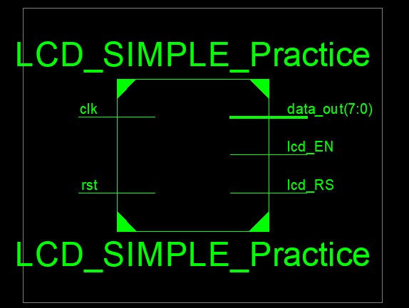

**TEST BENCH**

LIBRARY ieee;

USE ieee.std_logic_1164.ALL;

## -- Uncomment the following library declaration if using

-- arithmetic functions with Signed or Unsigned values

## --USE ieee.numeric_std.ALL;

ENTITY LCDTEST IS END LCDTEST;

## ARCHITECTURE behavior OF LCDTEST IS

-- Component Declaration for the Unit Under Test (UUT)

## COMPONENT LCD_SIMPLE_Practice PORT(

rst : IN std_logic; clk : IN std_logic;

## lcd_RS : OUT std_logic; lcd_EN : OUT std_logic;

data_out : OUT std_logic_vector(7 downto 0)

## );

END COMPONENT;

## --Inputs

signal rst : std_logic := '0'; signal clk : std_logic := '0';

## --Outputs

signal lcd_RS : std_logic; signal lcd_EN : std_logic;

## signal data_out : std_logic_vector(7 downto 0);

-- Clock period definitions constant clk_period : time := 10 ns;

## BEGIN

-- Instantiate the Unit Under Test (UUT) uut: LCD_SIMPLE_Practice PORT MAP (

## rst => rst, clk => clk,

lcd_RS => lcd_RS, lcd_EN => lcd_EN, data_out => data_out

## );

-- Clock process definitions clk_process :process

## begin

clk <= '0';

## wait for clk_period/2; clk <= '1';

wait for clk_period/2; end process;

## -- Stimulus process stim_proc: process begin

rst<='1';

## -- hold reset state for 100 ns. wait for 100 ns;

rst<='0';

## --din<="00101010";

wait for 100 ns;

## rst<='1';

--din<="00101010";

## -- hold reset state for 100 ns. rst<='0';

--din<="00101010";

## wait for 100 ns; rst<='1';

--din<="00111111";

## --hold reset state for 100 ns. wait for 100 ns;

rst<='0';

## wait for 100 ns;

-- insert stimulus here wait;

## end process;

END;

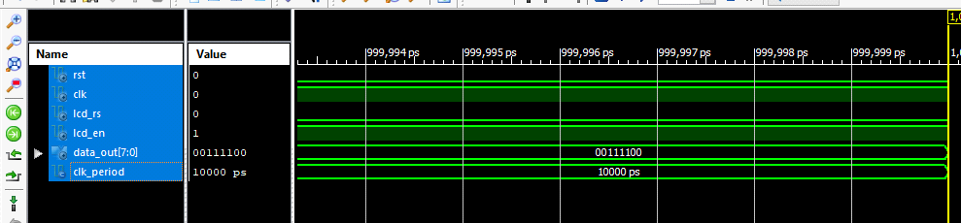

**UCF FILE (LCD)**

NET data(0) LOC = P62; NET data(1) LOC = P63; NET data(2) LOC = P64; NET data(3) LOC = P65; NET data(4) LOC = P67; NET data(5) LOC = P68; NET data(6) LOC = P71; NET data(0) LOC = P72; NET clk LOC = P183; NET reset LOC = P102;

# * Final Report *

## =====================================================================

====

## Final Results

RTL Top Level Output File Name : LCD_SIMPLE_Practice.ngr Top Level Output File Name : LCD_SIMPLE_Practice Output Format : NGC

## Optimization Goal : Speed

Keep Hierarchy : No

## Design Statistics

# IOs 12

## Cell Usage :

# BELS 83

|  |  |  |
| --- | --- | --- |
| #  # | GND  INV | : 1  : 1 |
| # | LUT1 | : 20 |
| # | LUT2 | : 2 |
| # | LUT3 | : 5 |
| # | LUT4 | : 11 |
| # | MUXCY | : 20 |
| # | MUXF5 | : 1 |
| # | VCC | : 1 |
| # | XORCY | : 21 |
| # FlipFlops/Latches 36 | | |
| # | FDC | : 34 |
| # | FDCE | : 1 |
| # | FDP | : 1 |

## # Clock Buffers 1

## # BUFGP 1

## # IO Buffers 11

## # IBUF 1

## # OBUF 10

=====================================================================

## ====

Device utilization summary:

## Selected Device : 3s400pq208-5

Number of Slices: 23 out of 3584 0%

## Number of Slice Flip Flops: 36 out of 7168 0%

|  |  |  |  |
| --- | --- | --- | --- |
| Number of 4 input LUTs: | 39 out of | 7168 | 0% |
| Number of IOs: | 12 |  |  |
| Number of bonded IOBs: | 12 out of | 141 | 8% |
| Number of GCLKs: | 1 out of | 8 | 12% |

Partition Resource Summary:

## No Partitions were found in this design.